REVI_FOOD CHATBOT
NLP Course Project, Milestone 1: Data Preprocessing Pipeline (Documentation)
Team: Eiad, Ali, Yassin | Data: Google Maps restaurants and reviews, Fifth Settlement, Rehab and First Settlement (Cairo)
Submitted files:
- NLP_Milestone1_Cleaning_EDA_Done.ipynb: dataset section, restaurant (places) cleaning and EDA (Eiad)
- NLP_pipeline_Yassin_done_0b3644.ipynb: reviews EDA and the NLP preprocessing pipeline (Yassin)
- This document: the full documentation of all four required parts (Ali)

1. Problem Definition

1.1 Problem statement and motivation
Google Maps shows each restaurant as one average number plus hundreds of reviews written in Egyptian Arabic, English, Arabizi and emojis. A diner cannot read them all, and the stars alone are a weak signal: in our data 68% of all 6,120 reviews give 5 stars (4,168), so most places look equally good. What people actually praise or complain about (food, service, price, ambiance, waiting time) is hidden inside the review text.
The project turns this text into usable information. The long-term product is a recommendation chatbot that answers questions such as 'best pizza in Fifth Settlement' with the top 5 restaurants, their rating, the most frequent positive and negative opinions from reviews, phone number and map link. The chatbot is a retrieval and ranking layer, not a generative model, so it cannot invent phone numbers.

1.2 Objectives
- Build a cleaned, documented bilingual (Arabic and English) corpus of restaurant reviews and restaurant metadata for New Cairo.
- Design a preprocessing pipeline that handles Egyptian Arabic spelling, elongated letters, emojis, Arabizi and code-switching without throwing away sentiment information.
- Train and compare sentiment classifiers (TF-IDF baselines against transformer models such as AraBERT, MARBERT and XLM-R) on weak labels from stars, evaluated with Macro-F1 because the classes are imbalanced.
- Extend the sentiment task to aspects (food, service, price, ambiance, delivery/wait) and use the results to rank restaurants in a chatbot demo.

1.3 Target users and application domain
- Diners in New Cairo who read Arabic, English or both and want a fast answer.
- Restaurant owners and managers who want to see what customers praise or criticize.
- Researchers in Arabic NLP who need a small, documented dialectal review corpus.
- Domain: restaurant recommendation and customer-opinion mining.

1.4 Research question
To what extent do star ratings reflect the sentiment expressed in Egyptian Arabic and English restaurant reviews, and does a text-based sentiment classifier provide a more reliable signal than star ratings alone for ranking restaurants?
Sub-questions:
- Which Arabic preprocessing choices (normalization, elongation handling, emoji handling) most affect sentiment classification performance on dialectal reviews?
- On a small, imbalanced corpus (about 2.4k usable text reviews), does a fine-tuned Arabic or multilingual transformer outperform a TF-IDF baseline, as measured by Macro-F1?

1.5 NLP task
The main task is review-level sentiment classification into three classes (negative, neutral, positive). Labels come from the star rating: 1-2 stars negative, 3 neutral, 4-5 positive. The second task is aspect-based sentiment analysis. An optional third task is query understanding (extracting cuisine and area from a question) using rules first. The split for training and testing is made by restaurant, so reviews of one place never appear in both training and test sets.

2. Dataset
Item | Description
Dataset name | Cairo (New Cairo) Restaurants and Reviews, Google Maps
Sources | Google Maps place pages and public reviews (link)
Link | Google Maps Scraper  - Rehab/First Settlement (Link1)  - Fifth Settlement (Link2)  Google Maps Reviews  - Link1  - Link2
Records | 684 places (290 Fifth Settlement, 394 Rehab/First Settlement); 6,120 reviews, of which 2,855 have written text and 3,265 are rating-only; 306 places have reviews
Place fields | 73 raw fields, 31 kept after cleaning, for example placeId, title, categoryName, address, totalScore, reviewsCount, phone, website, menu, openingHours, latitude, longitude
Review fields | reviewId, placeId, title, text, stars, publishedAtDate, originalLanguage, responseFromOwnerText, textTranslated
Target labels | Sentiment from stars (weak labels): negative 706, neutral 112, positive 2,037. A hand-annotated gold subset is planned for Milestone2.
Languages | Arabic (mostly Egyptian dialect), English, Arabizi, and mixed Arabic/English
Collection method | Apify scrapers: compass/crawler-google-places for places (many narrow searches by cuisine and area, in English and Arabic) and compass/google-maps-reviews-scraper for reviews. Review dates range from 2019-01-09 to 2026-10-25.
Join key | placeId links each review to its restaurant
Privacy | Reviewer names, IDs, photos and URLs are dropped. Raw reviews are shared only with the instructor.
The data has two parts: restaurant metadata (structured, needs data cleaning) and review text (unstructured, needs the NLP pipeline).

3. Exploratory Data Analysis
The EDA has eight analyses, split by data type. Section 3.1 covers the restaurants and section 3.2 the reviews, with two figures for each.
Required topic | Where it is covered
Dataset overview | Tables in 3.1 and 3.2
Data quality (missing values, duplicates, empty texts) | Tables in 3.1 and 3.2
Text characteristics (length, tokens) | Table in 3.2 and Figure 4
Task-specific analysis (sentiment, class imbalance, Arabic NLP) | Figures 3 and 4, and the Arabic NLP findings in 3.2

3.1 Restaurant data (684 places)
Check | Result
Places and fields | 684 places; 73 raw fields reduced to 31
Duplicate placeId | 0
Closed places | 0
Places without a rating or review count | 42
Most missing fields | description 95%, neighborhood 90%, menu 88%, locatedIn 76%, website 59%, price 48%
Repeated names (possible branches) | 11 names; each branch has its own placeId and is kept (for example 5 Papa Johns branches)
Category labels | 90 different labels; 85 places have the vague label 'Restaurant'
Fields available | opening hours 78%, popular times 68%, menu link only 12%
Figure 1. Top restaurant categories.
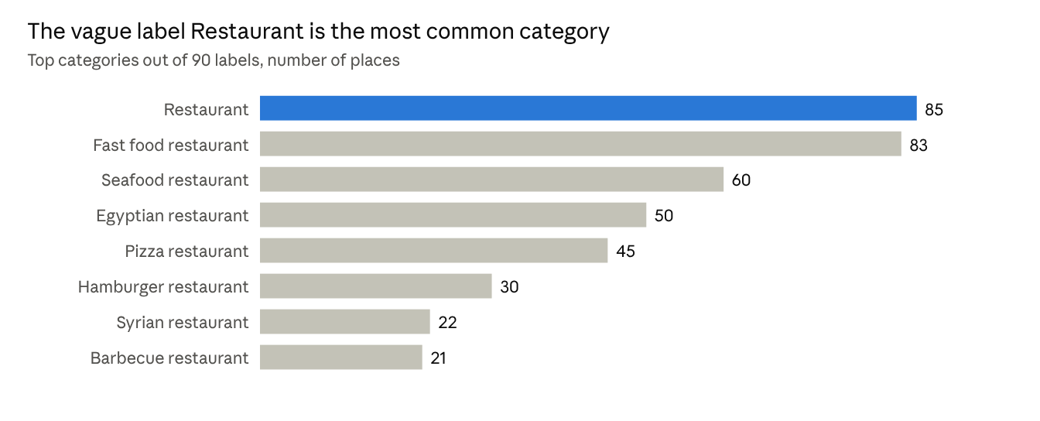
Source: restaurants_metadata_clean.csv, 684 places
What it shows: the category labels are noisy. The vague label 'Restaurant' is the most common, so categories need to be grouped into about 10-15 cuisine classes before the chatbot can filter by cuisine.
Figure 2. Place ratings by area.
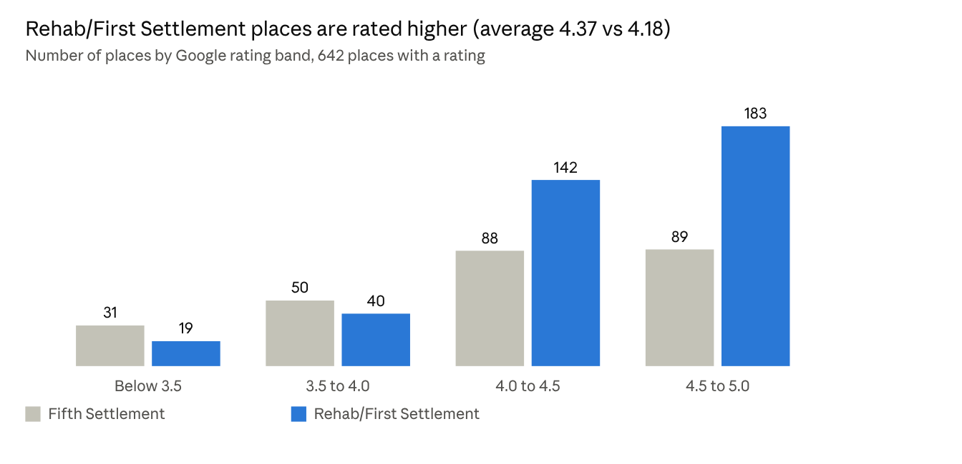
Source: restaurants_metadata_clean.csv, 642 places with a rating (42 have none)
What it shows: most places are rated 4.0 or higher in both areas, but Rehab/First Settlement is rated higher on average (4.37 against 4.18 in Fifth Settlement), and it has more places in the top band. Because most ratings are high, the average score alone does not separate good from average restaurants.

3.2 Review data (6,120 reviews)
Check | Result
All reviews / with written text / without text | 6,120 / 2,855 (47%) / 3,265
Duplicate texts | 161 (flagged, not deleted)
Very short (fewer than 3 words) | 424
Usable for modeling | 2,415
Text length (words) | mean 18.1, median 10, maximum 464
Median words: negative / neutral / positive | 15 / 15.5 / 8
Share of reviews that include text, by stars | 1 star 75%, 2 stars 58%, 3 stars 32%, 4 stars 26%, 5 stars 45%
Reviews containing emoji | 13.2%
Elongated letters | 5.5% of Arabic, 2.5% of English, 44% of Arabizi reviews
Figure 3. Sentiment distribution (from stars).
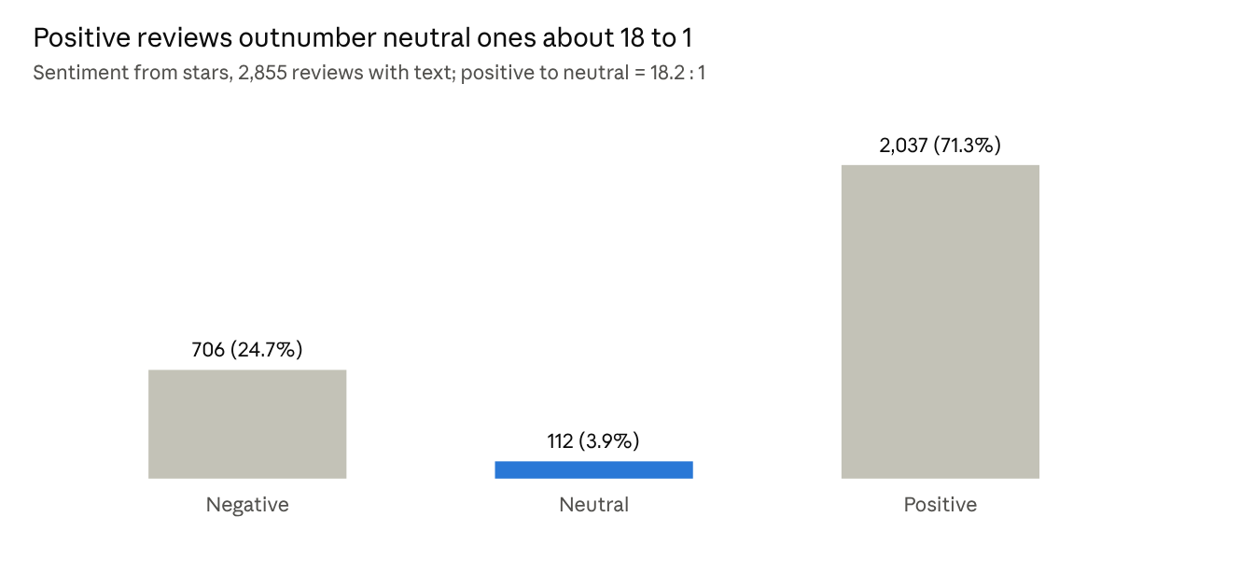
Source: reviews_clean.csv, 2,855 reviews with text
What it shows: the classes are strongly imbalanced. Positive reviews outnumber neutral ones about 18 to 1, so plain accuracy would be misleading and Macro-F1, class weights or resampling are needed in Milestone 2.
Figure 4. Language mix.
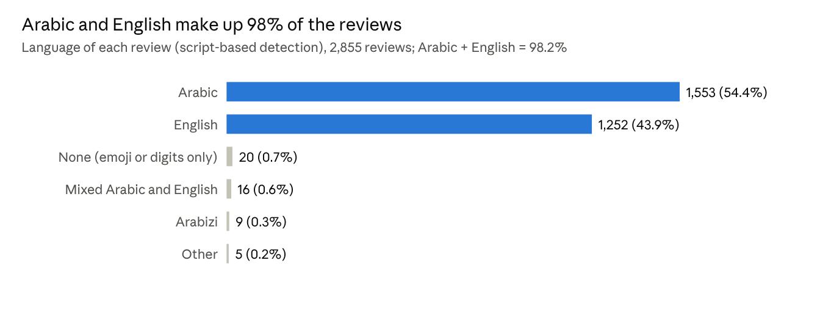
Source: reviews_clean.csv, 2,855 reviews with text
What it shows: Arabic and English together make up 98.3% of the reviews, so the pipeline mainly has to handle these two. Arabizi (9 reviews), mixed Arabic/English (16) and other languages are rare but appear as error-analysis cases.
Differences between the sentiment classes. Negative and neutral reviews are about twice as long as positive ones (median 15 words against 8), and unhappy customers write text more often than happy ones. Example reviews from the data:
- Negative: 'Overpriced, small portions, weird vibes. We have to pay 100...'
- Neutral: 'Comfortable place and Good staff...'
- Positive: 'Good Prices. Friendly Staff. Clean Place'
Arabic NLP characteristics. The reviews show Egyptian dialect, inconsistent spelling (alef and ya variants, diacritics), elongated letters used for emphasis, emojis, Arabizi with digits for Arabic letters (for example 7 for ح), and code-switching between Arabic and English. These are the reasons for the pipeline in the next section.

4. NLP Preprocessing Pipeline
The pipeline is implemented in Python (pandas, re, emoji, scikit-learn) in Yassin's notebook. Design rule: the original text text_raw is never modified. Every lossy step writes to a new column, so no useful information is removed automatically.

4.1 Operations, purpose and justification
# | Operation | What it does | Why it fits this dataset
1 | Noise and owner-reply removal | Removes URLs, phone-like numbers, invisible characters and odd symbols; collapses whitespace; cuts off an English machine translation that the scraper appended to some Arabic reviews; checks that no review is a copy of an owner reply | Google reviews contain noise. Owner replies are stored in a separate field, and none leaked into the text (0 found). Emojis are kept.
2 | Arabic normalization | Unifies alef variants, turns ى into ي, removes diacritics and tatweel; ة to ه is optional and off by default | Egyptian Arabic spelling is inconsistent, so one word appears in many forms
3 | Repeated-letter reduction | Arabic: 3 or more of the same letter become 1; English: 3 or more become 2; a flag has_elongation keeps the emphasis signal | Elongation fragments the vocabulary, but the flag keeps the sentiment information
4 | Emoji handling | Keeps emojis in text_clean and creates a second version with emojis converted to words | Emojis carry strong sentiment, and many tokenizers drop them
5 | Language detection | Labels each review as Arabic, English, mixed, Arabizi, none or other, using script ratios and a heuristic for digits inside Latin words | The corpus is bilingual, so later models may need per-language handling
Deliberately not applied automatically: stopword removal, stemming and emoji stripping on the main text, because they remove useful information (for example the negation in 'not good'). A stopword-reduced version exists only as a separate optional column that keeps negations.

4.2 Additional steps for modeling
Step | Column | Purpose
Weak sentiment labels from stars | sentiment | Labels for Milestone 2
Model-ready text (lowercase, emojis as words) | text_model | One consistent version for models
Tokenization | tokens, n_tokens | Token distribution and TF-IDF
Optional stopword reduction (keeps negations) | text_tfidf | For TF-IDF only
Usability flag | usable | Flags short, duplicate and non-Arabic/English reviews without deleting them
Split by restaurant (about 70/15/15) | split | No restaurant appears in both train and test
Final clean text | text_final | The single clean column recommended for models

4.3 Five before and after examples (real reviews)
Example 1: appended machine translation removed (operation 1).
- Before (811 characters): an Arabic review, a blank line, then an English translation beginning 'The food is somewhat okay and acceptable, but unfortunately the service is extremely poor...'
- After: only the Arabic text remains, ending with 'فلا يستحق الزيارة بتاتا'.
- Why: the scraper stores a machine translation inside text for some Arabic reviews. Left in, it distorts language detection and the vocabulary. 7 reviews were affected.
Example 2: repeated letters, Arabic (operations 2 and 3).
- Before: احلى مطعم ف العالم الخدمه ممتازه والاكل خطيرررررر
- After: احلي مطعم ف العالم الخدمه ممتازه والاكل خطير
- Why: the elongated word joins its normal form, and ى becomes ي. has_elongation is set to true so the emphasis is not lost.
Example 3: Arabic normalization and punctuation (operation 2).
- Before: الاكل أسوأ ما يكون ، الأحجام صغيرة. الاكل اتأخر جداً.
- After (text_clean): الاكل اسوا ما يكون ، الاحجام صغيرة. الاكل اتاخر جدا.
- After (text_final): الاكل اسوا ما يكون الاحجام صغيرة الاكل اتاخر جدا
- Why: the alef variants and the diacritic are unified, so spelling variants map to one form, and text_final removes punctuation.
Example 4: noise, English elongation and emoji (operations 1, 3 and 4).
- Before: Hossssaaaaaam is the goat cashier in chery shop. 1515151515151515 🐐🐐🐐🐐🐐
- After (text_final): hossaam is the goat cashier in chery shop goat goat goat goat goat
- Why: the long digit string is removed, the letter repeats are capped, and emojis become words that a text-only model can use.
Example 5: Arabizi detection (operation 5).
- Before: 2a da bgad aw7ash 7aga do2taha f 7ayaty
- After: language label arabizi, text unchanged.
- Why: digits such as 2 and 7 inside Latin words stand for Arabic letters, so these reviews need different handling from normal English. Only 9 reviews are Arabizi.

4.4 Pipeline v2 (optional experiments, not applied automatically)
The first pipeline cannot finish all the work, so these ideas are implemented as separate columns and will be compared with v1 on the same split in Milestone 2.
Idea | Result on our data
Light Arabic stemming | Works for some words, rough on dialect
Dialect-aware normalization | Needs a larger Egyptian lexicon
Arabizi transliteration | Crude, and only 9 reviews are Arabizi
Near-duplicate detection | 9 near-duplicates found beyond exact copies
Emoji sentiment tags | To be compared with emoji names
Negation marking | Needs an experiment to prove it helps
Class weights | negative 1.3, neutral 8.23, positive 0.47
Rule-based aspect tagging | food 1,286, service 762, ambiance 536, price 194, delivery/wait 168; 1,017 reviews with no aspect
Bayesian average place score | Prevents places with few reviews from getting a perfect score
AraBERT tokenization | Fragments unsegmented Egyptian text, so pre-segmentation or a dialect model such as MARBERT should be tested

5. Problems Faced and How We Handled Them
Problem | Solution
3,265 reviews have no text, but their ratings are needed for scores | Kept all 6,120 reviews for ratings and used the 2,855 with text for NLP
Arabic words got an extra letter after repeat reduction | Separate rules: Arabic reduces to 1, English caps at 2
The Arabizi detector flagged English reviews (35 flagged, 9 real) | Required longer tokens, removed ambiguous words and required a minimum share of Arabizi tokens
English text appeared inside Arabic reviews | The scraper appended machine translations; removed them using the textTranslated field and a backup rule
The saved file looked unclean because it had several text versions | Added one final column, text_final, and documented which to use
File-name and cell-order errors in Colab | Pattern-based file loading, fixed cell order, and a full Restart and Run all check

6. Limitations
- Only 2,855 reviews have text and 2,415 are usable, which is small for deep models and should be checked against the project minimum.
- Neutral reviews are very rare (112), so the neutral class will be hard to learn.
- Star-based labels are weak (a 4-star review can still contain complaints), so a gold-annotated subset is planned.
- Language detection is based on script, so a review in another Latin-script language would be labeled English.

7. Team Contributions
Member | Contribution
Eiad | Dataset section (sources, fields, collection method), loading and cleaning of restaurant metadata, area mapping, duplicate and branch checks, restaurant EDA, Excel export
Ali | Problem definition (statement, motivation, objectives, target users, research questions, NLP task) and project documentation
Yassin | Review EDA (data quality, length, language, sentiment), NLP preprocessing pipeline, before/after examples, weak labels, split by restaurant and Pipeline v2 experiments

8. References and Links
- Notebook links:
- https://colab.research.google.com/drive/1zxpTOVhQa8WVsZBC7H1wkKvLWh4_h2zl#scrollTo=_j0ST3HlZe0u
- https://colab.research.google.com/drive/10qlvUWebgpgc6UoMUx8wDRPSRqmOoNFE#scrollTo=95huQyeoRXav
- Apify. Google Maps Scraper (compass/crawler-google-places). https://apify.com/compass/crawler-google-places
- Apify. Google Maps Reviews Scraper (compass/google-maps-reviews-scraper). https://apify.com/compass/google-maps-reviews-scraper
- Antoun, W., Baly, F., & Hajj, H. (2020). AraBERT: Transformer-based Model for Arabic Language Understanding. arXiv:2003.00104.
- Pedregosa, F. et al. (2011). Scikit-learn: Machine Learning in Python. Journal of Machine Learning Research, 12, 2825-2830.
- McKinney, W. (2010). Data Structures for Statistical Computing in Python. Proceedings of the 9th Python in Science Conference.
- Wolf, T. et al. (2020). Transformers: State-of-the-Art Natural Language Processing. EMNLP 2020, System Demonstrations.
- emoji Python library. https://pypi.org/project/emoji/

9. Requirements Checklist (Milestone 1)
Requirement | Where
Project title, problem statement and motivation | Section 1.1
At least 3 objectives (we list 4) | Section 1.2
Target users and application domain | Section 1.3
At least one research question (we list 4) | Section 1.4
NLP task description | Section 1.5
Dataset name, sources, link, record counts, fields, labels, languages, collection method | Section 2
EDA with at least 4 analyses: overview, data quality, text characteristics, task-specific | Section 3 (tables and Figures 1 to 4)
Pipeline with at least 4 operations | Section 4.1 (5 operations)
At least 5 before/after examples with purpose and justification | Sections 4.1 and 4.3
Runnable notebook with example outputs | Submitted notebooks
Contributions of each member | Section 7
References for datasets and resources | Section 8

